Feature Scaling & Distribution Analysis

Objective:
Ensure that numerical features are on compatible scales for ML algorithms and converge efficiently during training.
Numerical Feature Encoding
Step 1: Check Distribution Characteristics
We used histogram plots and computed skewness/kurtosis to determine the scaling method.
- Standardize if:
  - Skewness is close to 0 (|skewness| < 0.5)
  - Kurtosis is moderate (-1 < kurtosis < +1)
- Normalize if:
  - High skewness or extreme kurtosis
# plot histograms
df_final[num_features].hist(figsize=(15, 12), bins=30, edgecolor='black')
plt.tight_layout()
plt.show()

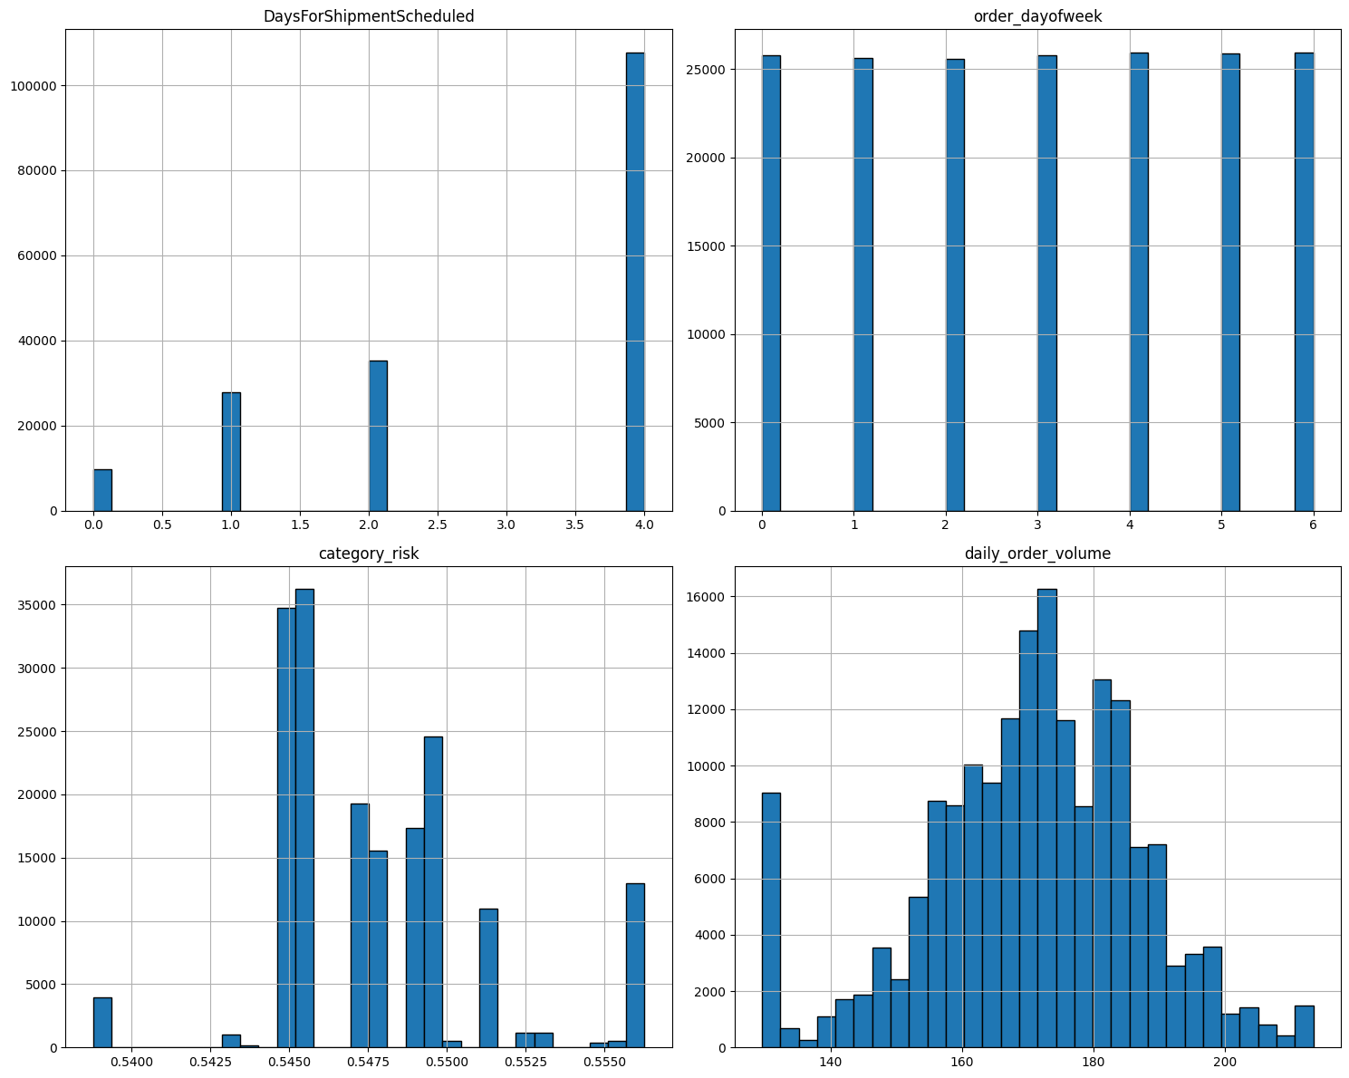
# Check Skewness and Kurtosis
for column in num_features:
skewness = df_final[column].skew()
kurtosis = df_final[column].kurtosis()
print(f"{column} - Skewness: {skewness}, Kurtosis: {kurtosis}")

DaysForShipmentScheduled - Skewness: -0.7319982842174512, Kurtosis: -1.022948807002554
order_dayofweek - Skewness: -0.0066650373370776604, Kurtosis: -1.2513154595076643
category_risk - Skewness: 0.6010060673987747, Kurtosis: 0.9795669840852184
daily_order_volume - Skewness: -0.40820184326883696, Kurtosis: 0.32792524688612845

From above Histogram and by checking Skewness and Kurtosis, We can conclude that we should perform standarization for daily_order_volume, order_dayofweek and NOrmalization for DaysForShipmentScheduled, category_risk.

For Standarization we will perform StandardScaler and for Normalization we perform MinMaxScaler.
StandardScaler → can produce negative (<0) and >1 values (z‑scores).
MinMaxScaler → forces everything into the [0, 1] interval.

norm_features = ['DaysForShipmentScheduled', 'category_risk']
stand_features = ['order_dayofweek', 'daily_order_volume']

Categorical Feature Encoding
Strategy:
- OrdinalEncoder: for ordinal categorical feature with known order
- OneHotEncoder: for low-cardinality nominal features
- BinaryEncoder: for high-cardinality nominal feature (CustomerCity)
# Categorical Feature Groups
ordinal_features = ['ShippingMode']
ordinal_categories = [['Standard Class', 'Second Class', 'First Class', 'Same Day']]

onehot_features = ['OrderRegion', 'Market']

hc_cat = ['CustomerCity']

Pipeline for Preprocessing
To apply multiple transformations consistently, we constructed a ColumnTransformer and wrapped it in a Pipeline.
# ColumnTransformer for separate scaling
preprocessor = ColumnTransformer(transformers=[
('norm', MinMaxScaler(), norm_features),
('std', StandardScaler(), stand_features),
('ord', OrdinalEncoder(categories=ordinal_categories), ordinal_features),
('ohe', OneHotEncoder(handle_unknown='ignore'), onehot_features),
('binary', BinaryEncoder(), hc_cat)
], remainder='passthrough') # Keep the other columns (if any) as it is
# Full pipeline
pipeline = Pipeline(steps=[
('preprocess', preprocessor)
])

# Fit and transform
preprocessed_data = pipeline.fit_transform(df_final)

Output Feature Recovery
We retrieved the transformed column names and built a new DataFrame:
# Recover the output feature names
feature_names = pipeline.named_steps['preprocess'].get_feature_names_out()
column_names = [name.split('__', 1)[1] if '__' in name else name
for name in feature_names]
column_names

Final Output Storage
To save and reuse the preprocessed dataset:
df_transformed.to_pickle('preprocessed_data.pkl')

We also re-plotted histograms of the scaled numerical features to ensure that transformations were applied correctly.

Model Training, Testing & Evaluation

Objective:
Train multiple machine learning models to predict Late Delivery Risk (binary classification) and evaluate their performance based on accuracy, precision, recall, F1-score, and confusion matrix.
Step 1: Dataset Splitting
The data was first split into training and testing sets to evaluate generalization performance.
y = df['Late_delivery_risk']
X = df.drop(columns='Late_delivery_risk')

X_train, X_test, y_train, y_test = train_test_split(X, y, test_size=0.2, random_state=42)

- Target variable (y): Late_delivery_risk (1 = Late, 0 = On Time)
- Test size: 20%
- Random state: 42 (to ensure reproducibility)

Step 2: Model Selection
A set of diverse models was selected to cover both simple interpretable and complex non-linear approaches:
models = {
'Logistic Regression': LogisticRegression(...),
'Decision Tree': DecisionTreeClassifier(...),
'Random Forest': RandomForestClassifier(...),
'Gradient Boosting': GradientBoostingClassifier(...),
'XGBoost': XGBClassifier(...),
'K-Nearest Neighbors': KNeighborsClassifier(...),
'Neural Network': MLPClassifier(...)
}

Note: Class weights were balanced for applicable models to handle any class imbalance.
Step 3: Model Training & Evaluation
Each model was trained and evaluated using:
- Accuracy (overall correctness)
- Precision (positive predictive value)
- Recall (sensitivity or true positive rate)
- F1-score (harmonic mean of precision and recall)
- Confusion Matrix
# Train, predict, and evaluate each model
for name, model in models.items():
print(f"\n{name}")
model.fit(X_train, y_train)
y_pred = model.predict(X_test)

acc = accuracy_score(y_test, y_pred)
print(f"Accuracy: {acc:.4f}")

print("Classification Report:")
print(classification_report(y_test, y_pred))
print("Confusion Matrix:")
print(confusion_matrix(y_test, y_pred))
Evaluation Results Summary
Model | Accuracy | Precision (Late) | Recall (Late) | F1-score (Late) | Notable Insights
Logistic Regression | 0.6875 | 0.79 | 0.58 | 0.67 | Performs better on "On Time", less recall for "Late"
Decision Tree | 0.6977 | 0.84 | 0.56 | 0.67 | Good at precision but weak recall for "Late"
Random Forest | 0.7005 | 0.84 | 0.56 | 0.67 | Similar to Decision Tree but slightly more stable
Gradient Boosting | 0.6927 | 0.84 | 0.54 | 0.66 | High precision, low recall
XGBoost | 0.7013 | 0.84 | 0.57 | 0.68 | Best balance among tree-based models
K-Nearest Neighbors | 0.7667 | 0.79 | 0.78 | 0.79 | Strong performer; best balance of metrics
Neural Network | 0.7319 | 0.79 | 0.70 | 0.74 | Good generalization; handles non-linearity well

Observations:
- Best Overall Accuracy: K-Nearest Neighbors (76.67%)
- Best Recall for Late Deliveries: Neural Network (70%)
- Best Precision for Late Deliveries: Multiple models tied at 84%
- Most Balanced Model: Neural Network and KNN
Next Steps:
- Perform cross-validation to confirm robustness.
- Use ROC-AUC to compare models on probability thresholds.
- Perform feature importance analysis for interpretability.
- hyperparameter tuning.
- Export the best model and deploy.

